Feedback
12/08/2026
Peer 1:
Received feedback on my usability (visibility of system status).
- Mentioned that it was difficult to know when the program had finished loading.
- Suggested that I may want to add a loading screen on the initial open of the app.
- I will implement a loading screen on launch, so that there is time for the app to initialise.
Peer 2:
Received feedback on my usability (aesthetics).
- I showed her 4 different colour schemes, she initially suggested that I should use a cool-blue scheme.
- I told her about the aesthetic I was aiming to achieve, and she agreed that my current scheme was suitable.
- I will keep my current colour scheme
Peer 3:
Received feedback on my usability (help and documentation)
- Complained that he didn’t understand what the settings sliders actually did.
- I will add a short explanation to the calibration and settings page to make sure the user knows how to use them and what they do.

Testing – General Code
Date: 31/08/2026
What’s being tested: Error handling. Running the program without a settings file should not throw any errors. Instead, a settings file with default values should be created.
Pass/Fail: Fail, running the program without the settings file throws an error.
Changes made:
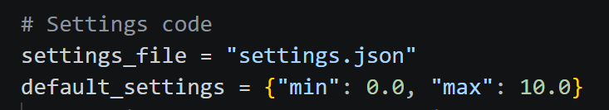
Removed the hardcoded default values, put them in a dictionary for ease of editing.
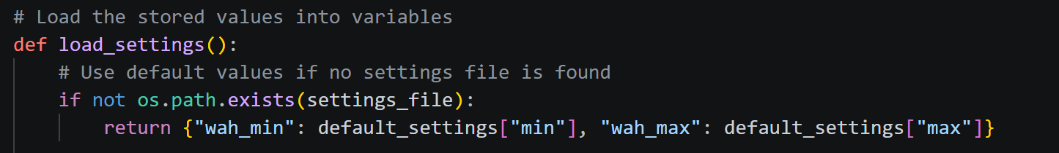
If the settings file is not found during loading, it will return the default values for the sliders to use instead of crashing the program.

Date: 31/08/2026
What’s being tested: Expected output when settings sliders are dragged. Releasing the slide should immediately update the value of the setting in the settings.json file.
Pass/Fail: Pass, the value is updated on release.
Changes made: No changes needed

Testing – MIDI and Face Tracking
Date: 13/08/2026
What’s being tested: Testing that Python is sending MIDI commands as expected. This is a core function of the webapp, so it is important to make sure it works as smoothly as possible.
Pass/Fail: Fail, the MIDI commands are sent but there is something causing it to have excessive latency between the mouth moving and the MIDI changing.
Changes made:
The issue was caused by the location of the line which opens the MIDI port. Originally, it was under a loop which made it reopen every frame. This introduces extra lag which caused the latency.
I fixed it by opening the MIDI port before the face tracking loop, so that it only does it once. The MIDI commands are now a lot more responsive than before.
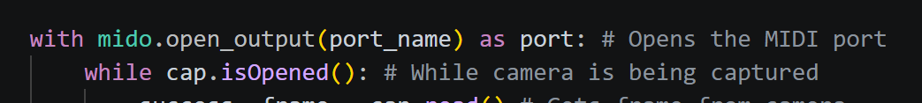

Date: 31/08/2026
What’s being tested: Error handling. Program should not crash or throw errors when there is no MIDI port.
Pass/Fail: Fail, program throws an error when ran without a MIDI port open. Also bad visibility of system status since user is not shown any notification,
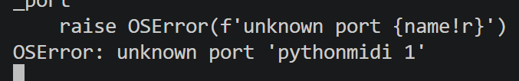
Changes made:
Implemented an error notification that appears if no MIDI port is dected.
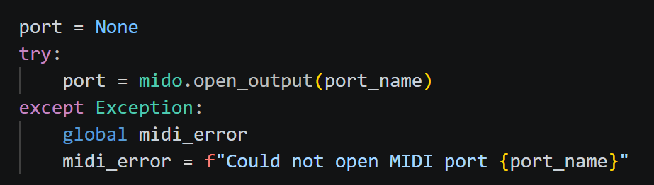

Testing – Web UI
Date: 20/08/2026
What’s being tested: Mobile users are able to switch tabs smoothly
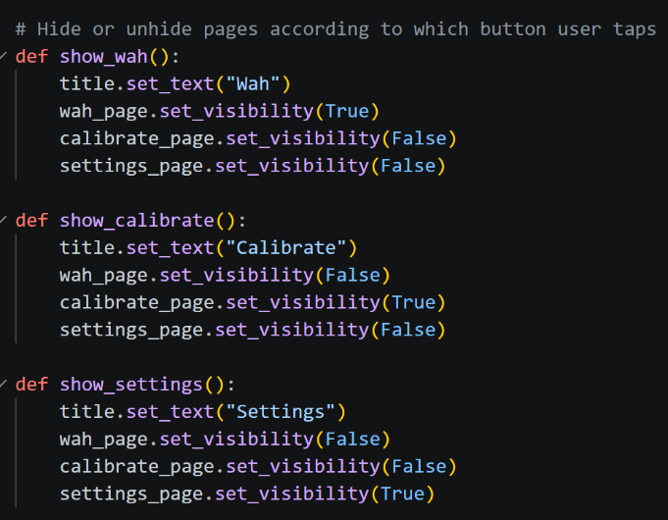
Pass/Fail: Fail. Switching tabs causes the MIDI to freeze briefly. I believe this is due to the need for NiceGUI to redraw the page every time a new page is opened.
Changes made: Made the program draw all three pages from the beginning. Then hiding and unhiding them according to which tab is open (as seen in the picture on the right). This means that the program only has to draw the pages once and not every time the user changes tabs.

Date: 31/08/2026
What’s being tested: Expected behaviour from UI elements. Wah gauge on main page should update in time according to the user’s mouth.
Pass/Fail: Fail, gauge does not update because the function that draws the gauge cannot access the updated wah percentage value. This means that the gauge only shows the original value of the shared dictionary.
Changes made: To troubleshoot, I isolated the thread.
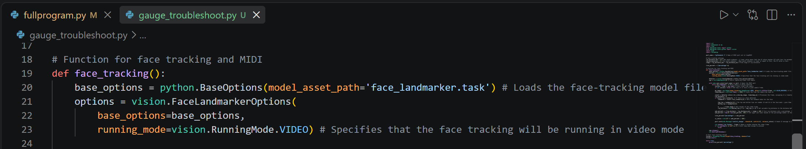
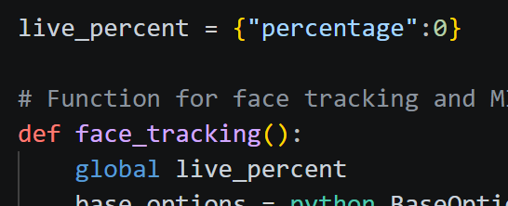
I think it may be a program scope issue, where the thread can’t modify the dictionary for the rest of the program. To test this, I will declare the global scope for the live_percent variable inside of the thread function.
This did not fix the issue.
While testing, I replaced the ui.timer line with a while True loop. This allowed the updated value to be accessed so it has to have something to do with the way NiceGUI works.

Date: 31/08/2026
What’s being tested: Responsive UI design. The UI should change depending on what screen the user is on. Screens wider than 1024px will be shown a desktop view with all three pages side by side. Whereas mobile screens will be shown a navigation bar and a header.
Pass/Fail: Pass, the program layout changes at my specified breakpoint.
Changes made: No changes needed

Date: 2/09/2026
What’s being tested: Usability aesthetics. Should have good contrast between the background and the text so that text is not hard to read.
Pass/Fail: Fail, contrast is mostly fine, but the close button on the error notification is too hard to see on the red background.
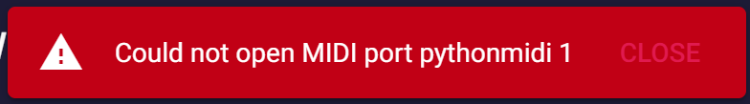
Changes made:
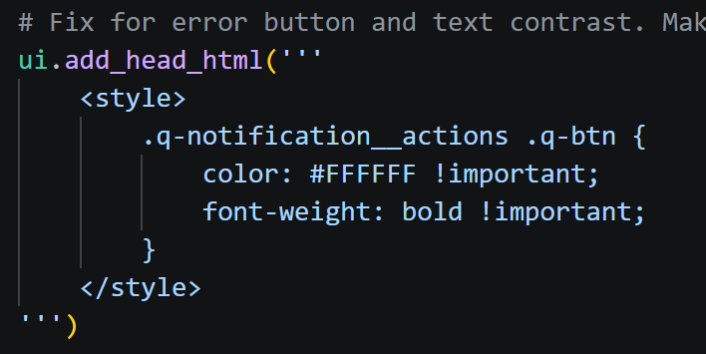
Added custom CSS rules to change the default Quasar notification styling. Makes the “Close” button white and bold to improve contrast.

